Sysmex Corporation
D-Project

SAP ABAP
Development Standards &
Naming Conventions

Version: 1.2

Contents
1. Document Information 5
1.1. Key Contacts 5
1.2. Document History 5
1.3. Approval 5
1.4. Reference Documents 5
2. Introduction 6
2.1. When to apply the Standards 6
2.2. Overall Guiding Standards 6
3. ABAP Naming Standards 8
3.1. Work Stream and Process Area IDs 8
3.2. ABAP Objects (External) 8
3.2.1. General 8
3.2.2. Enhancements 9
3.2.3. IDOC 10
3.2.4. Security 10
3.2.5. ABAP 10
3.2.6. Classes 11
3.2.7. WebDynpro and Floorplan Manager 12
3.2.8. WebDynpro UI Elements 12
3.2.9. LSMW 13
3.2.10. Print Forms 13
3.2.11. Data Dictionary 14
3.3. ABAP Objects (Internal) 15
3.3.1. Internal Declarations 15
3.3.1. Internal Declarations in class methods 16
3.3.2. Parameters in Function Modules / Forms 16
3.3.3. Parameters in Class Methods 17
3.3.4. Method names 17
3.4. Exceptions 18
4. ABAP/4 Programming Standards and Guidelines 19
4.1. Development Quality 19
4.2. SAP HANA Techniques 19
4.3. Object Orientated (OO) 19
4.4. Program Structure 19
4.4.1. “Traditional” Report Programs 19
4.4.2. General 20
4.5. Program Documentation and Comments 20
4.5.1. Main Documentation Block 20
4.5.2. Online Documentation 20
4.5.3. Comments 20
4.6. Data Definitions 21
4.6.1. Global/Local Data 21
4.6.2. Declaration 21
4.6.3. Constants and Hardcoding 21
4.6.4. Internal Tables 22
4.7. Error Handling 22
4.7.1. Exceptions 22
4.7.2. Return code 22
4.8. Modifications and Cloning 22
4.9. User Exits and Enhancements 23
4.9.1. Implicit Enhancements for Updates 23
4.9.2. Include exits 23
4.9.3. Switch Framework 23
4.10. Messages 25
4.11. Language Considerations 25
4.12. Report Output 26
4.12.1. Use S/4 HANA Embedded analytics Virtual data model and CDS views for Reporting output 26
4.13. Forms Output 27
4.14. Debugging 27
4.15. Maintenance/Correction of existing production code 27
4.16. Development Environment 28
4.16.1. ABAP Workbench Settings (SAP GUI) 28
4.16.2. ABAP Development Tools (ADT) 28
4.17. Obsolescence 28
4.17.1. Redundant Programs / Code 28
4.17.2. Obsolete SAP Modules 29
4.18. Unreleased Function Modules 29
4.19. Database Processing 29
4.19.1. Z/Y Table Creation 29
4.19.2. Database Reads 30
4.19.3. Data Updates (SAP data) 30
4.19.4. Data Updates (non-SAP data) 31
4.20. Security 33
4.20.1. Authorization Checking 33
4.20.2. SQL Injection Protection 33
4.20.3. Change logging 34
4.20.4. User Accounts and Passwords 34
5. ABAP Performance Standards 35
5.1. General Code Structure 35
5.2. DB accesses 35
5.3. Memory 36
5.4. Conclusion 36
6. ABAP Standards and Procedures for “Lift and Shift” objects 37
6.1. Object copy 37
6.2. Object Remediation 37
6.2.1. Code corrections 38
6.2.2. Extended Program Check 39
6.2.3. Code Inspector 40
7. Appendices 41
7.1. Appendix A – Code Comment Block 41
7.2. Appendix B – Workstream ID and SAP Modules 42
7.3. Appendix C – TR Naming Convention 43

- Document Information
  - Key Contacts
Name | Email | Phone
Rachael Niao | rachael.niao@au.ey.com | +61 402 302 273
  - Document History
Date | Name | Version | Description of Changes
28/10/2019 | Rachael Niao | 0.1 | Initial Creation
25/10/2020 | Ratnesh Sisodiya | 0.2 | Template Adjustment and Reviews
29/10/2020 | Amrish Sharma | 1.0 | Marking the document version as 1.0, and removed Draft status
13/11/2020 | Elaine Pahang | 1.1 | Added Appendix for Workstream ID and synced <WS_ID> naming in the document
15/3/2022 | Robbin Singh | 1.2 | Added BRF+ naming
  - Approval
This document requires approval from the following individuals:
Name | Role/Team | Date | Signature
Yonekura Yasuo | S-Corp Leader | 26/10/2020 | Yonekura Yasuo
Goto Masaki | S-Corp Pre Leader | 3/09/2020 | Goto Masaki
Raphael Altewulf | RHQ Leader | 18/08/2020 | Raphael Altewulf
Malte Menzel | RHQ Leader | 18/08/2020 | Malte Menzel
  - Reference Documents
Document Name | Location
Database Logical Unit of Work (LUW) | https://help.sap.com/saphelp_nw70/helpdata/EN/41/7af4bca79e11d1950f0000e82de14a/frameset.htm
SAP LUW | https://help.sap.com/saphelp_nw70/helpdata/EN/41/7af4bfa79e11d1950f0000e82de14a/frameset.htm
ABAP Development Tools | https://help.sap.com/doc/2e9cf4a457d84c7a81f33d8c3fdd9694/LATEST/en-US/inst_guide_abap_development_tools.pdf

- Introduction
Development programming standards and consistent naming conventions will contribute significant time and resource savings for both the initial construction and long term maintenance of the SAP system. Addressing these standards prior to construction and adhering to them during construction is especially helpful when addressing the following:
- Migration into a production environment
- Facilitating knowledge transfer to future SAP development resources
- Long-term maintenance/expansion of custom development
- Future upgrades

Small amounts of effort now will prove beneficial for the overall project and SAP S/4 system. The objective of this document is to detail uniform program standards for the D-Project Development team, and to provide guidelines and useful information for programmers in the SAP S/4 environment.
This document defines the minimum requirements to accomplish for custom SAP developments.

  - When to apply the Standards
These standards apply to all new ABAP repository objects and existing custom developments, except for ‘Y’ or ‘Z’ objects created by SAP.
When modifying existing Custom Developments:
- If the program/object that needs to be modified complied with the standards listed in this document, then these standards are to be maintained in the new code.
- If the program/object was developed before these standards applied, then the changes made to the code must conform to these standards.
However, for the rest of the program/object, there is no need to re-write the code to comply with these standards, unless the existing code might cause a system or data integrity problem.

  - Overall Guiding Standards
The following paragraphs describe the rules for program development in Sysmex:
- Changes should not be made to standard SAP development objects unless they are endorsed by SAP or are approved by the Development and Integration manager, and the Design Authority.
- No custom object is allowed to perform a direct update to Standard SAP Tables as this can cause data inconsistency in the system.
- Documentation for all custom developments, excluding temporary objects not for transport, will be maintained and stored in the Sysmex document management system upon completion of the build.
- Before the creation of custom ABAP objects, existing objects will be reviewed to determine if they may be used as a template or potentially fill the requirement.
- All custom ABAP development objects will be named according to the ABAP Naming Standards.
- Online documentation will be utilized to describe program functionality to end users and functional leads. Online documentation is required for all ABAP objects.
- All ABAP objects must be able to support multiple languages, i.e. to use the text elements and translation tools. No hard coding of text is allowed.
- Before development begins, the functional design must have been signed-off. The development team have to provide the program, technical specification, component test plan and the check list before obtaining the sign-off from the functional team.

If the ABAP standards described above (or detailed in the following sections) cannot be followed for any reason (i.e. a breach is required), approval from the Integration and Development Lead is required before build commences.
Any development that breaches these standards without prior approval will be rejected.

- ABAP Naming Standards
  - Work Stream and Process Area IDs
An SAP implementation or support team is usually structured around business processes, SAP solutions or modules, or some combination thereof. The lowest level abbreviations will be used in object names as a namespace. In the example below a two-level organisation is shown split by 'Work Stream' for the higher level and 'Process ID' for the lower level, and ‘Region’ if required.

Work Stream ID (<WS_ID>) | Process Area ID (<PA_ID>) | Region  (<WS_ID_REG>)  (Region identifier will not be used for APAC, EMEA and US as these will be independent systems. We will try to leverage this in JEA and SCH as these might be based on same systems) | Description
e.g. RTR, OTC, WTD, etc | e.g. SD, PM | e.g. JEA, SCH, SAP, SAI, SEG | e.g. Forecast to Manufacture, Warehouse to Distribution, Source to Procure, etc
SYS |  |  | Systems / Basis  - Always check with the Development Lead before coding a ZSYS object.

  - ABAP Objects (External)
    - General
Object | Convention | Examples | Comments
Package or  Package Interface | Z<WS_ID> or  Z<WS_ID>_<PA_ID> -Main Package  Z<WS_ID>_<name> | ZOTC or  ZOTC_SD – Main Package  ZOTC_SD_BILLING – Sub Package | Process Area level packages can be created initially, but the preference is to create a package per logical grouping of developments. Give any Package Interfaces the same name as their corresponding Package.
Message Class | Z<WS_ID> or  Z<WS_ID>_<name> | ZOTC  ZOTC_SD | Use Process Area level classes for messages that might be reused.  Lower-level classes may be useful for individual developments with numerous messages.
Transaction codes | Z<WS_ID>_<name> | ZPTP_DELIVERY | Transaction description can explain what the transaction does. The code itself just needs to be unique, short and easy to remember. Suffixes can be used if different tcodes are needed e.g. for different org units, countries, or for display/change/create mode.

    - Enhancements
- When coding and enhancement, BAdI or CMOD you must never code directly into the enhancement point. Always create a class for your specific enhancement. Every enhancement must be encapsulated in its own Enhancement Class and must be self-contained.
- The enhancement place (spot, BAdI, CMOD include should only ever contain the method call to your class) Where more than one enhancement is to be implemented at an Enhancement point then the methods are to be called serially unless the enhancement point is one that allows multiple implementations.
Object | Convention | Examples | Comments
Composite Enhancement Implementation | ZCE_<WS_ID><name> | ZCE_PTP_GOODS_DISTRIBUTION | Should not be needed.  A composite enhancement implementation may be used to group together a number of discrete enhancements which form part of the same solution. However this should not be necessary when using a separate Package for each development, as this will do the same job.
Enhancement Spot Implementation (SE19) | ZEI_<name> or  ZEI_<name>_<variant> | ZEI_FAGL_MM_RECON  ZEI_SHIFT_PLANNING_E001  ZEI_SHIFT_PLANNING_GB | Name can be based on the name of the enhancement spot.  If the same enhancement spot is implemented multiple times as part of different developments, then some kind of variant can be appended - e.g. the Process Area ID or the filter value.
BAdI Implementation | Z<name> or  Z<name>_<variant> | ZFAGL_MM_RECON  ZREQ_ITERATION_SORT_GB  ZPUR_SE_PO_OUT_E001 | Name can be based on the name of the BAdI (may or may not be the same as the enhancement spot name).  Different variants may be needed, e.g. by Org Unit when the BAdI implementation can be chosen by a filter.
BAdI Class | ZCL_IM_<name> or  ZCL_IM_<name>_<variant> | ZCL_IM_FAGL_MM_RECON  ZCL_IM_REQ_IT_SORT_GB | Name and Variant should match those from BAdI implementation name, or be an abbreviation of them.
Project (Transaction CMOD) | Z<name> | ZAFAR002 | CMOD project name should be same as SMOD enhancement name starting with Z or Y and removal of one zero.  For e.g. If SMOD object is AFAR0002, you can define CMOD project as ZAFAR002.
Other types of enhancement:  - Implicit Enhancements  - Enhancement Points  - Enhancement Sections | ZIE_<name>  ZEP_<name>  ZES_<name> | ZIE_FAGL_MM_RECON  ZEP_SHIFT_PLANNING  ZES_SHIFT_PLANNING | Name could be based on the method / subroutine being enhanced.

    - IDOC
Object | Convention | Examples | Comments
IDoc Extension | Z<basic type>EXT | ZARTMAS05EXT | IDoc Extension
IDoc Segment | Z<name> | ZARTMASAPPEND | IDoc Segment
IDoc | Z<name> | ZARTMAS05 | IDoc
Message Type | Z<name> | ZARTMAS | Message Type
IDoc Extension | Z<basic type>EXT | ZARTMAS05EXT | IDoc Extension
Process Code | Z<name> |  | Inbound/Outbound Process code

    - Security
Object | Convention | Examples | Comments
Authorization Class | Z<WS_ID> | ZRTR | Create one authorisation class per Process Area.
Authorization Object | Z<WS_ID>_<name> | ZRTR_PLAN | Name used should be consistent with the name of the application the object is being created for.

    - ABAP
Object | Convention | Examples | Comments
Report | Z<WS_ID>_<name> or Z<WS_ID>_<name>_<variant> | ZOTC_DUNNING_LIST  ZOTC_PRICING_IMPORT_UKBQ
Module Pool | SAPMZ<WS_ID>_<name> | SAPMZRTR_AGED_DEBT | Transactions to be developed using Fiori/UI5  If screens needed in GUI code via a Function Group
Includes in Programs or Module Pools | Z<name> or  MZ<name> (Module pools) | Include names are proposed by the SAP system and structured logically by the developer.  Conventions for suffix:  - TOP for Top Includes  - F01-F99 for Subroutines  - I01-I99 for PAI Modules  - O01-O99 for PBO Modules  - C01-C99 for class Definitions/Implementations
Includes for VOFM routines | Z<WS_ID>_VOFM_<standard name> | ZOTC_VOFM_RV64A941
Menu | Z<name> | ZMAIN
Dynpro numbers | 0001 -> 9999 | 0100
Function group  (created manually) | Z<WS_ID>_<text> | ZPTP_STOCK_UTILITIES  ZOTC_LAST_MILE_API
Function group  (generated table maintenance) | name of the function group = name of table | ZFI_REF_DOC
Function modules | Z_<WS_ID>_<text> | Z_PTP_STOCK_UNIT_CONVERT  Z_WTD_DELIVERY_GET | Process Area used should match that in the Function Group. Text should ideally start with a noun (the object) and then contain a verb (the action to perform).
Database Procedure Proxy | Z<WS_ID>_DP_<name> | ZPTP_DP_STOCK_UNIT_CONVERT  ZWTD_DP_DELIVERY_GET | Create in Eclipse to consume native HANA stored procedures in ABAP, if an ABAP Managed Stored Procedure (AMDP) cannot be used instead. The <name> part should be based on the procedure name in HANA.

    - Classes
Object | Convention | Examples | Comments
Class | ZCL_<WS_ID>_<name> | ZCL_PTP_VENDOR | The name should consist of nouns and always be singular.
Exception Class | ZCX_<WS_ID>_<name> | ZCX_PTP_VENDOR | Typically might have one exception class per normal class, containing numerous error texts.
Interface | ZIF_<WS_ID>_<name> | ZIF_PTP_BUSINESS_PARTNER | The name should consist of nouns and always be singular.
Enhancement Class | ZCE_<Enh.PointID>_<name> | ZCE_MB_DOCUMENT_BADI
Adobe Interface Class | ZCF_<Adobe_Interface_name> | ZCF_OTC_DUNNING | For Adobe Interface named ZAI_OTC_DUNNING  - Note: Class must contain a static ENTRY method that is called from the Adobe Interface.
Generated Class | As generated by SAP |  | Some such classes might be Data Provider class (OData), Persistence classes.  At all times, use the name generated by SAP.

    - WebDynpro and Floorplan Manager
Object | Convention | Examples | Comments
Web Dynpro Application or WD Application Configuration | Z<WS_ID>_<name> or Z<WS_ID>_<name>_<variant> | ZPTP_VENDOR_OVERVIEW  ZOTC_LAST_MILE_GB | Variants could be for different Org Units or countries for example.
Web Dynpro Component | Z<WS_ID>_<name> | ZPTP_VENDOR_OVERVIEW | For main components use same name as in the Application
Web Dynpro Component Configuration | <WD Comp name>_<variant> | ZOTC_LAST_MILE_OVP_GB | Variants could be for different Org Units or countries for example.
WD Assistance Class | ZCL_AS_<name> | ZCL_AS_VENDOR_OVERVIEW | <name> should be based on the WD Comp name.
FPM Feeder Class | ZCL_FD_<name> | ZCL_FD_KNKA_LIST  ZCL_FD_VENDOR_FORM
Windows | W_<name> | W_ORGANIZER
View (in WD Component) | V_<name> | V_HEADER
Component usage | U_<used_component> | U_EXCEPTION_POPUP
Inbound-Plug | IP_<name> | IP_DEFAULT
Outbound-Plug | OP_<name> | OP_EXIT

    - WebDynpro UI Elements
Object | Convention | Examples | Comments
BusinessGraphics | BGR_<name> | BGR_SALES
Button | BTN_<name> | BTN_SAVE
ButtonRow | BTR_<name> | BTR_DETAILS
Caption | CPT_<name> | CPT_COLUMN
Checkbox | CHK_<name> | CHK_ERRORLOG
DropDownByIndex | DDI_<name> | DDI_COUNTRY
DropDownByKey | DDK_<name> | DDK_REGION
FileUpload | FUD_<name> | FUD_CONTRACT
Group | GRP_<name> | GRP_FORM
HorizontalGutter | HOG_<name> | HOG_ROADMAP
InputField | INP_<name> | INP_NAME
InteractiveForm | IFO_<name> | IFO_CUSTOMS
Label | LBL_<name> | LBL_INPUT
LinkToAction | LTA_<name> | LTA_SEARCH
LinkToURL | LTU_<name> | LTU_VENDOR
RadioButton | RBT_<name> | RBT_MALE
RadioButtonGroupByIndex | RBI_<name> | RBI_GENDER
RadioButtonGroupByKey | RBK_<name> | RBK_TYP
RoadMap | RMP_<name> | RMP_DIMENSIONS
RoadMapStep | STP_<name> | STP_DIMENSION
Table | TBL_<name> | TBL_ADDRESS
TextEdit | TXE_<name> | TXE_INFO
TextView | TXV_<name> | TXV_INTRO
TimedTrigger | TTR_<name> | TTR_NOTIFY
TransparentContainer | TCO_<name> | TCO_TABLE
Tray | TRY_<name> | TRY_FORM
Tree | TRE_<name> | TRE_SIMPLE
TreeNodeType | TNT_<name> | TNT_FOLDER
TreeItemType | TIT_<name> | TIT_FILE
ViewContainerUIElement | VCU_<name> | VCU_ROADMAP

    - LSMW
Object | Convention | Examples | Comments
LSMW - Project | Z<Project Name> | ZUNITED_P2
LSMW - Subproject | <WS_ID>_<Subname> | RTR | Work stream and an optional identifier
LSMW - Object | <Object Name>_<Action> | BP_CREATE  MATERIAL_PLANT_EXTEND  PIR_LOAD  PIR_UPDATE | Name - could be the business object name, name of IDOC being used, or name of a table being updated.

    - Print Forms
      - Adobe Forms
Object | Convention | Examples | Comments
Form | ZAF_<WS_ID>_<name> or  ZAF_<WS_ID>_<name>_<variant> | ZAF_OTC_DUNNING1_GB | Each Org Unit may require their own form variants (e.g. with different branding)  Further variants may be necessary by country and/or language.
Interface | ZAI_<WS_ID>_<name> or  ZAI_<WS_ID>_<name>_<variant> | ZAI_OTC_DUNNING | It may be possible to re-use Interfaces an Interface definition across multiple Org Units.

      - Smart Forms
Object | Convention | Examples | Comments
Form | ZSF_<WS_ID>_<name> or  ZSF_<WS_ID>_<name>_<variant> | ZSF_OTC_DUNNING1_UKBQ | Each Org Unit may require their own form variants (e.g. with different branding)  Further variants may be necessary by country and/or language.
Style | Z<name> or  Z<name>_<variant> | ZBODY_TEXT  ZHEADER_GB | Styles may be used across Process Areas, and may be or may not be Org Unit specific.
Text Module | Z<name> or  Z<name>_<variant> | ZHQ_ADDRESS_GB | Text Modules may be used across Process Areas, and may be or may not be Org Unit specific.

      - SAP Script
Object | Convention | Examples | Comments
Form | Z_<WS_ID>_<name> | Z_OTC_CUST_ST
Print Program | Z<WS_ID>_<name>
Standard text | Z_<Form name>_<Description>_<Counter>
Styles | Z<name>

    - Data Dictionary
      - SE11
Object | Convention | Examples | Comments
Domain | Z<name> | ZBELNR_REF | A custom Domain is only required to define allowed values - otherwise can define a Data Element with a built-in type.
Data element | ZDE<name> | ZDEBELNR_REF | Always make use of standard Data Element or Domain names where appropriate (in this case BELNR).
Database table | Z<WS_ID>_<name> | Z_RTR_REF_DOC
Database text table | <table name>_T | Z_RTR_REF_DOC_T | Needed for any description field that should be translatable.
Fieldname | <name> | BELNR_REF | Use data element name without any leading Z
View (SE11) | ZV<name> | ZVREF_DOC1
Structure | ZS<name> | ZSPOITEM
Table type | <structure_name>_T | ZSPOITEM_T | While creating table types, we should consider keys and access types (standard sorted or hash table) of the table types
Search help | ZH<name> | ZH_BELNR_REF
Lock object | E<database table> | EZREF_DOC
Append Structures | ZZ<database table> | ZZMARA | Note that the first 3 characters of an Append name cannot be an underscore.  Within an Append structure, use one or more Include structures to actually hold the fields. The Include structures have the advantage that they may be reused in other objects, whereas the Append structure cannot.
Field in Append | ZZ_<name> | ZZ_BELNR_REF | Fields should be held in an Include structure within the Append. Field names must start ZZ_ to ensure they do not clash with standard field names.

      - Eclipse
Object | Convention | Examples | Comments
ABAP CDS View  - Definition  - SQL database View  - CDS View Entity  - parameters | Z<WS_ID>_DDL_<name>  Z<WS_ID>_SQL_<name>  Z<WS_ID>_CDS_<name>  p_<name> | ZOTC_DDL_ORDER_REF  ZOTC_SQL_ORDER_REF  ZOTC_CDS_ORDER_REF  P_LANGU, P_CURR | Object containing the definition  View visible in SE11, can be used for data typing.  Use this object in SELECT statements.  Fields are CDS views should be named as Camel case.
External Dictionary View | Z<WS_ID>_HV_<name> | ZOTC_HV_ORDER_REF | Create in Eclipse to consume native HANA views in ABAP, if CDS views are not sufficient. The <name> part should be based on the view name in HANA.

  - ABAP Objects (Internal)
    - Internal Declarations
Object | Convention | Examples | Comments
Parameter (selection screen) | P_<name> | P_MATNR
Select-options | S_<name> | S_VBELN
Constants | LC_<name>  GC_<name> | use GC_ (global constant) e.g. for global declaration in TOP-Includes use LC_ (local constant) e.g. for declaration in subroutines | <name> of a constant should not include the value itself
Types | LTV_<name>  GTV_<name> | Variable | Rarely used
 | LTY_<name>  GTY_<name> | Structure type
 | LTT_<name>  GTT_<name> | Table type
Data | LV_<name>  GV_<name> | local / global variable; e.g. LV_DATE
 | LS_<name>  GS_<name> | local / global structure;  e.g. LS_MARA
 | LT_<name>  GT_<name> | local / global table  e.g. LT_MARA | No need to indicate table type.
 | LTR_<name>  GTR_<name> | local / global range table  e.g. LTR_MATNR type range of MATNR | Do not use RANGES – always declare a range table
 | LO_<name>  GO_<name> | local / global object reference
 | LR_<name>  GR_<name> | local / global data reference  e.g. lr_data type ref to data | For data references other than class objects.
Field Symbols | <xx_name> | Add brackets to regular naming conventions;  e.g. <lv_matnr> type matnr  <ls_mara> type mara  <gt_data> type any table
Statics | SV_<name> | Variable | Avoid these wherever possible – use classes instead.
 | SS_<name> | structure
 | ST_<name> | internal table

    - Internal Declarations in class methods
Object | Convention | Examples | Comments
Constants | LC_<name>  GC_<name> | use LC_ for declaration in methods  use GC_ for declaration in class attributes
Types | TV_<name> | Variable
 | TY_<name> | Structure type
 | TT_<name> | Table type
Instance attributes  (public, private, protected) | MV_<name>  MS_<name>  MT_<name>  MO_<name> | mv_matnr (variable)  ms_mara (structure)  mt_mara (table)  mo_material (object)
Static attributes  e.g. CLASS-DATA  (public, private, protected) | GV_<name>  GS_<name>  GT_<name>  GO_<name> | Variable  Structure  Internal table  Internal table Object
Method data  (local declarations) | LV_<name>  LS_<name>  LT_<name>  LR_<name>  LO_<name>  LX_<name>  <xxname> | Same as for subroutines:  Variable  Structure  Table  Data Reference  Object Reference  Exception Reference  Field Symbol
Class definition | LCL_<name>  GCL_<name> | local and global (e.g. TOP-Include) class definitions
Class interface definition | LIF_<name>  GIF_<name> | local and global (e.g. TOP-Include) interface definition, e.g. for ALV usage

    - Parameters in Function Modules / Forms
Object | Convention | Examples | Comments
IMPORTING Parameter (function modules) or USING Parameter (subroutines) | IV_<name>  IS_<name>  IT_<name> | Variable  Structure  Table
EXPORTING Parameter  (function modules only) | EV_<name>  ES_<name>  ET_<name> | Variable  Structure  Table
CHANGING Parameter (subroutines or function modules) | CV_<name>  CS_<name>  CT_<name> | Variable  Structure  Table
TABLES Parameter (subroutines or function modules) | IT_<name>  ET_<name>  CT_<name> | Use IT_, ET_ or CT_ to reflect how the table is being used. | - In general, TABLES parameters are obsolete - use the other parameter options with a Table Type instead. An exception is RFCs and IDOCs, where the official guidance is still to use TABLES.

    - Parameters in Class Methods
Object | Convention | Examples | Comments
Import-Parameter | IV_<name>  IS_<name>  IT_<name>  IO_<name> | Variable  Structure  Table  Object Reference
Export-Parameter | EV_<name>  ES_<name>  ET_<name>  EO_<name> | Variable  Structure  Table  Object Reference
Changing-Parameter | CV_<name>  CS_<name>  CT_<name>  CO_<name> | Variable  Structure  Table  Object Reference
Returning-Parameter | RV_<name>  RS_<name>  RT_<name>  RO_<name> | Variable  Structure  Table  Object Reference

    - Method names
Object | Convention | Examples | Comments
SET- / GET-Methods for attribute access | SET_<attribute_name>,  GET_<attribute_name> | set_status  get_name
Methods for event handling | ON_<event_name> | on_button_click
Methods for type conversion | GET_<attribute_name>_AS_<new_type> | get_longtext_as_string
Methods that deliver a Boolean value (true, false) | IS_<adjective> | is_open  is_active | - These methods should not return any exceptions  Always return a result of type abap_bool.
Methods for checks | CHECK_<objective> | check_authorization
ABAP Managed Database Procedures | <method name>_AMDP | check_authorization_amdp | Use AMDP suffix to indicate the method is implemented on the database. Otherwise the same naming guidance applies.

  - Exceptions
For the following scenarios, the rules prescribed in Section 3 do not apply:
- Code generated via a “wizard” does not need to be re-developed to comply with variable naming standards listed in Section 3.3.
- Function Module parameters do not need to adhere to the naming conventions listed in Section 3.3.2 if the Function Module is called dynamically (eg. Call function T123-fmod). This is often the case for BTE implementations, ALE/IDOC function modules, etc.
- Method names for inherited or redefined classes.

  - BRF+
Object | Convention | Examples | Comments
BRF+ Application | Z<WS_ID>_ APP_BUSINESS_VARIABLE | ZPTD_ APP_BUSINESS_VARIABLE
BRF+ Decision Table | Z<WS_ID>_ DT_<RICEFWID>_<NAME> | ZPTD_DT_F1025_PLANT_BARCODE
BRF+ Function | Z<WS_ID>_ FN_<RICEFWID>_<NAME> | ZPTD_ FN_F1025_PLANT_BARCODE

- ABAP/4 Programming Standards and Guidelines
The purpose of this section is to define the basic standards that all developed programs must comply with. This section describes the rules surrounding the use of ABAP features and components.
  - Development Quality
All Developers need to consider the following quality aspects during coding:
- Reusability
Code should not be continually rebuilt. Common code should be encapsulated in classes.
- Correctness
The program should return accurate and consistent results.
- User-friendliness
Familiar look and feel and behaviour, easy navigation.
- Stability
The program behaves predictably and there are no sudden stops or system dumps.
- Performance
Quick response times
- Maintainability
Code is readable, easy to follow and maintain.

  - SAP HANA Techniques
With the introduction of HANA, traditional coding techniques where data is selected from the data base and manipulated in memory (“data to code” approach) may not always yield the best results.
SAP now recommends that more processing is pushed to the data base layer (“code to data” approach, also known as “code pushdown”). This can be achieved by the use of CDS views and/or ABAP Managed Database Procedures (AMDP), where calculations and other logic is performed as part of the data retrieval process in the data base layer.
Developers need to become familiar with the new features and techniques that have become available due to SAP HANA and incorporate this into code design and development.
Also refer to the comments listed in section 5.2.

  - Object Orientated (OO)
All developers should be using Object Orientated coding techniques where possible. The use of forms and function modules should be limited to the cases where these techniques are still required.
  - Program Structure
    - “Traditional” Report Programs
Events that are not used in a new program should be removed for clarity. Use local classes and methods instead of forms to encapsulate code within the program.
Avoid using global data. Do not declare variables after any event as this makes them global by default.
Do not use Logical Databases to retrieve data.
Data entered on the selection screen should be validated against the appropriate master data / configuration tables before execution of the main selection logic.
Size of a procedure (FORM. ENDFORM.) and nesting depth.
SAP recommends,
- less than 150 steps in a procedure.
- no more than 5 nests
    - General
For readability purposes, one command per line is the preferred approach. more than one ABAP steps in single line should be avoided.

  - Program Documentation and Comments
    - Main Documentation Block
The main documentation block contains a detailed description of the Program/Function Group/Class/Method, the author, maintenance history, brief description and so on.
Refer to Appendix A for the comment block template and guidelines on how to complete this.
    - Online Documentation
Online documentation will be utilized to describe program functionality to end users and functional leads. Online documentation is required for all ABAP objects.
    - Comments
Each form and method implementation should contain comments that outline the purpose of the module (its function) and the parameters used.

For example:
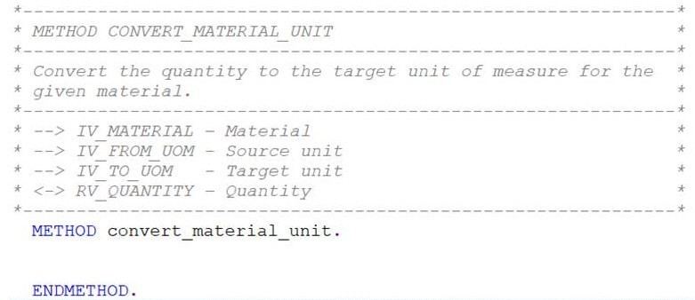

Within code, include meaningful comments that will help future developers with their understanding of the logic. Each small logical group of code should have comments.
Comments should describe the intent or rationale, and not just state the obvious (eg. The comment “Add 1 to the counter” before a “add 1 to lv_counter” statement is not necessary).
For example:
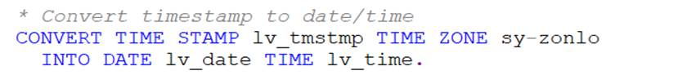
Is more readable as:
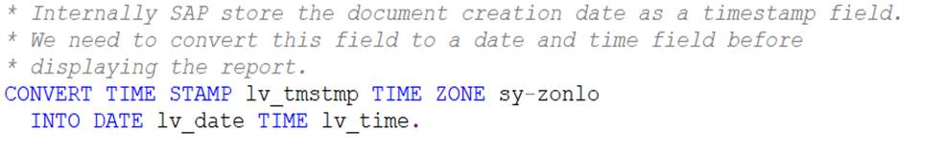
Comments are encouraged to be lengthy and include design decisions and business requirements where appropriate.
Comments on a line of code is acceptable if it adds to the readability, eg.
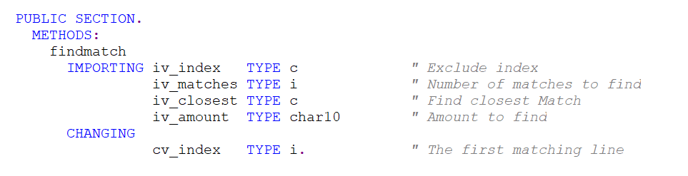

  - Data Definitions
    - Global/Local Data
Use local variables whenever possible within subroutines/methods for modularization purposes. However, frequently used forms/methods within one program call can use global variables if this will improve performance.
    - Declaration
All data should be typed or defined by the data dictionary.
The use of inline declarations of data is allowed.
    - Constants and Hardcoding
Hard coding of data should be avoided. Use constants if the data is unlikely to change (eg. Document type) or the development relates to a particular business case (eg. For a particular company code). In some instances consider using global OO Interfaces and/or classes to store constants. This allows for where-used analysis to determine change impact for future maintenance.
If a value is likely to change, then other techniques for the maintenance of these values (via Z-table, BRF+, etc.) needs to be considered. The technique selected will depend on the frequency of the changes, who will perform the changes (business/technical team), security restrictions, and so on.

    - Internal Tables
Do not declare tables with a header line unless this is required for backwards compatibility purposes.
Consider declaring internal tables as sorted or hashed with a defined key. Consider the use of secondary indexes over creating new tables and moving data if a table needs to be accessed by different keys.
Access internal tables via keys or binary search (after sorting).
The use of field-symbols to hold the current line is the preferred approach when looping through tables to read and/or update data, for example:
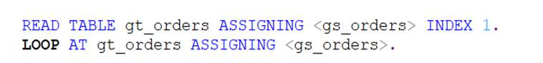
Do not read data into memory that is not required. Filter unnecessary data via SQL.
Use the FREE statement to clear global tables once they are no longer needed by the program.

  - Error Handling
    - Exceptions
Always catch exceptions and deal with them in your code. Not handling exceptions can lead to short dump if the exception is raised with the RAISE statement.
Catch exception selectively; only handle exceptions you can handle properly and propagate others to the next level of the call stack. To propagate an exception you must not catch it. The system will automatically look up the stack for an explicit “catch” for that exception.
The only exception is where the function or methods you are calling raises the exception with the message statement, and raising a message is the desired outcome.

    - Return code
Always check and handle SY-SUBRC and catch exceptions, or comment as to why it is not required.

  - Modifications and Cloning
- Modifications to SAP code are not permitted.
- The cloning of SAP code (to create a ‘Z’ / ‘Y’ version) is also not permitted.
- Compatibility views are required to map tables from the old world (e.g. COSS) to tables of the new S/4HANA world (e.g. ACDOCA) so that old coding can still work without changes. Refer to the note 2000002, 1976487, 2219527, 2221298, 2185026, 2156822, 2206980, 2217299 and 2198647 for further detail.

  - User Exits and Enhancements
SAP provides many ways to enhance standard logic by providing user exit points in the code. Where multiple options are supplied by SAP, the recommendation is to use (in the following order):
- BAdI implementation
- Enhancement Spot, Explicit Enhancement, SMOD/CMOD, BTE
- Include exits
- Implicit Enhancement, including Class and Function Enhancements, where no changes to SAP standard data or behaviour occurs
Multiple use BAdIs allow for many independent implementations and are the preferred option if available.
All exit code should be developed in a modular format using one or more classes per enhancement
Do not code directly into the exit “include” placeholder.

    - Implicit Enhancements for Updates
- Implicit Enhancements may be deployed but approval must be obtained from the Development Lead for each time an implicit enhancement is to be deployed. Implicit enhancements should be implemented using the same coding techniques/structure as standard SAP enhancements (refer to section 3.2.2 of this document.

    - Include exits
- Where SAP has supplied the “include” style of exit (eg. MV45AFZZ), and there are no other alternatives available, the exit needs to be developed as a Z multiple-use BAdI with a predefined interface.
- Where the exits use the X/Y structures and tables (such as XLIPS/YLIPS in delivery processing), the rules governing how these tables are to be updated must be adhered to (see OSS notes 178328 and 415716).
    - Switch Framework
- Enhancement Switch Framework enables to introduce a flexible mechanism to conditionally activate source code. Source code can be directly activate / deactivate directly in production environments without the need of a transport.
  - For example: An organization runs a global ERP instance and receives a requirement to have a specific User-exit or BADI enhancement only to be active for a specific Plant / Sales Organization / Company code.
  - Enhancement function supports to active / deactivate piece of source code enabling the switch framework, which can be achieved using TCODE: SM34

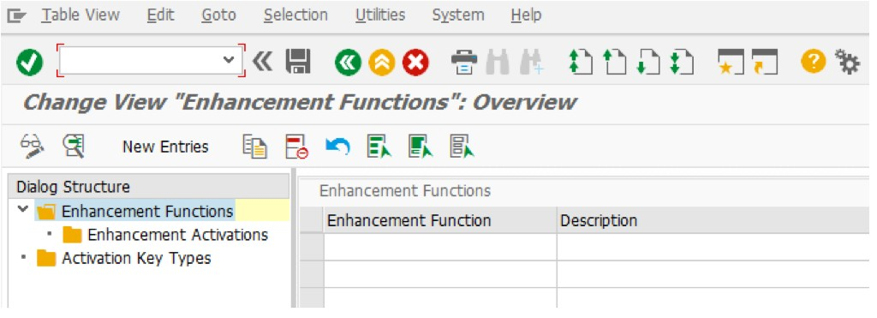
Example: Activation of enhancement only for specific username or Activation for a specific company code
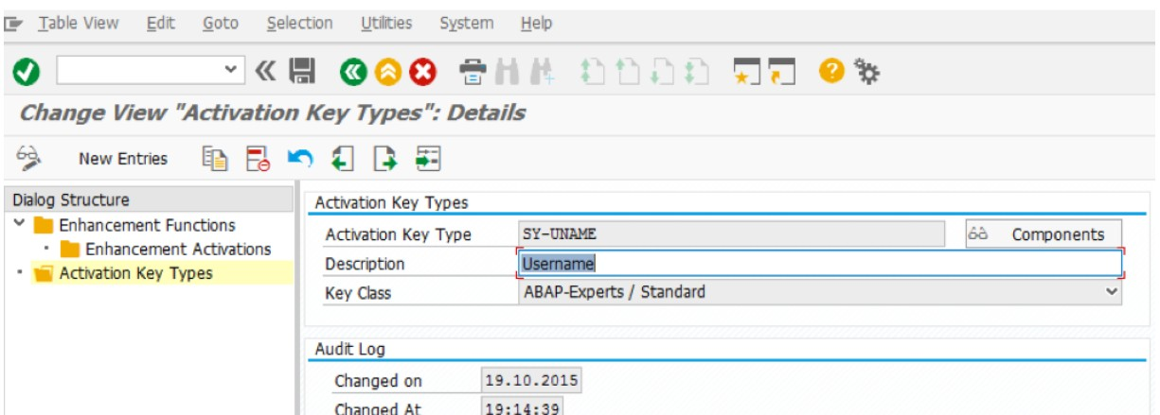

Example: Enhancement to be active for Sales Org with value – 1001., Activation flag to be enabled / disabled according to the logic
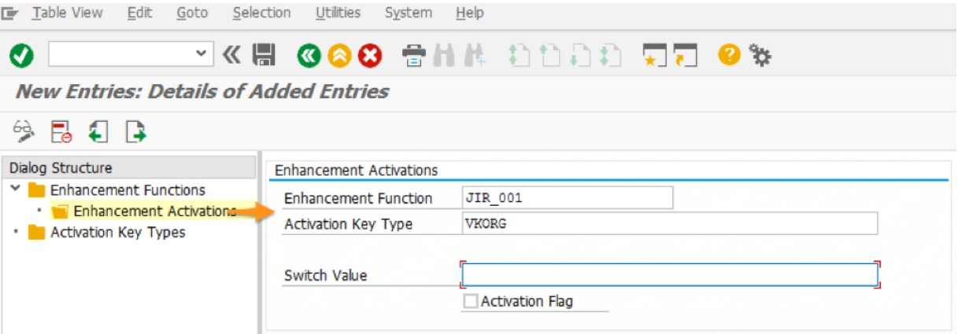

  - Messages
All Error messages are to be implemented via specific MESSAGE ID’s (not 000 or 999).
Where appropriate, a detailed long text should be maintained which includes:
- Problem short text
- Detailed description
- What to do (i.e. Writing “contact support” should be avoided. Put something meaningful like “Determine the intended receiver system and notify support”)
- Admin / Support – Any additional technical information to aid in analysis, and what should the support person do about it. Something meaningful like “configure the receiver logical system using transaction BD64 and the partner profile in WE20”.
A separate message class should be used for large developments, developments with multiple components, or a development which has its own package. Shared message classes should be used only in small developments or simple reports.
All placeholders in the message should be numbered rather than generic. i.e. Use “&1”, “&2” within the message body:

For messages built in structures/tables (eg. During BAPI developments), consider adding the message to the code via an un-called “message” statement so that the message can be found via the SAP where-used list, i.e.
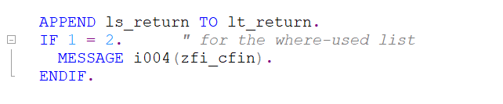

  - Language Considerations
In order to allow text to be converted into other languages without the need for a code change, the following practices should be followed when handling text:
- Use Text objects within code.
Example: gv_title = ’Hello’(001) or gv_title = text-001.
- Avoid building sentences in output. For other languages this may not make sense.
Example: concatenate text-001 text-002 into gv_variable
- On Selection Screens, if you are declaring select-options or parameters that are referencing SAP dictionary fields, then use the “Dictionary Reference” option.
Example: 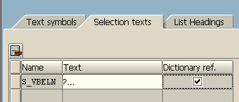
- Do not write programs that use fixed positioning in the output
Example: Write: /0 ‘Item: ‘(001), 7 vbap-posnr
- When defining internal tables to output via ALV, reference these to a Z-structure where the Component Type (or Data Element) are SAP standard.
- Avoid abbreviations as column headings or report text; use the full correct text.
- In ABAP programs using Screen Painter, use SAP dictionary fields as field labels
Example: 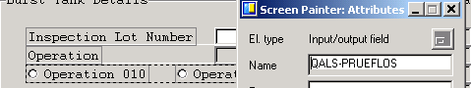
If using a SAP field label is not appropriate, then try to avoid hard-coding labels via the %#AUTOTEXTnnn method. Instead, create a Data Dictionary structure (eg. ZQMS_ZQIG0013_SCREEN_LABELS) to hold the labels for the screen. The Data Dictionary Component Types (or Data Element) field labels can then be translated and updated for other languages without the need for modifying the screen.
- If comments are required on the screen, define these as fields and move text objects to them in “before output” processing.
Create variable user-defined function codes in GUI status, and move text objects to these.

  - Report Output
The use of ALV Grid (OO and/or Factory methods) must be used to present data for end-user reports. “Write” statements should be discouraged and only used for simple reporting when the program is infrequently used (eg. One off update programs) The use of ALV with IDA is recommended wherever applicable
    - Use S/4 HANA Embedded analytics Virtual data model and CDS views for Reporting output

  - Forms Output
Before commencing any FORMS development you must confirm that the WRICEF to be developed contains either:
- Confirmation from Sysmex that the form is approved for external use
(this confirmation should include corporate style guidance including font/colour/layout/logo etc.)
- Confirmation that the form is for internal use and does not require corporate approval

All new forms should be developed in the Adobe Forms where possible. If Adobe Forms cannot be used, then Smart Forms is the next option. SAP Script should only be used as a last resort.
When developing Adobe forms output (non-interactive), the following points need to be considered:
- Colour, size, and location of any logos, ensuring that they display at or close to their native resolution to reduce Form file size.
- Fonts, colours, and font size – for performance only ADOBE Reader native fonts should be used.
- Style and orientation of Field Labels should be consistent for the entire form e.g. left or right justified
- Style, size and orientation of Field content should be appropriate to field content – left justified for text, right justified for numerical data
- The use of and dimensions of the ‘Snap-to grid’
- Layout and use of Master Pages and any repeating data
- The use of Section headings (fonts, italics, size, bold) borders, boxes, backgrounds, colours
- The use and location of page numbers/page X of Y
- The use and location of dates
- Do not embed code in the Adobe Forms Interface. If code must be executed in the interface then an appropriate class named ZCL_AI_<formname> should be built. It must contain at least one method and the method is to be called MAIN. That method is passed and input fields and should return a structure containing the fields used in the form. This ensures that any logic executed in an Adobe form is stored external to the forms interface and included in the Development Workbench “Where-Used” indexing.
- Use S/4 HANA new output management wherever applicable.

  - Debugging
All debugging code must be removed from a program before migration to a controlled environment (i.e. Quality Assurance, Production). This includes breakpoints and any code associated with testing.

  - Maintenance/Correction of existing production code
When changing production code, the “Change History” section in the main program comment block must be updated.
The code corrections made should also have accompanying comments that explain the reason for the code changes. For example:
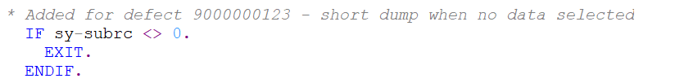
If major coding changes are to occur, indicate the changes in an extended description and revamp the program. The program, however, must comply with the standards defined in this document at the time the modification is to take place and not rely on the old standards when the program was originally developed. This will ensure the reworked program is up to date on new standards and practices.
Do not leave old commented out code in the source, since previous versions of the code are captured by SAP Version management.

  - Development Environment
    - ABAP Workbench Settings (SAP GUI)
- Use Pretty Print (with Indent set) to automatically indent all statements.
- Use uppercase for keywords. This setting is available in ABAP Editor.
- Leave the default settings for Unicode (active), fixed point arithmetic (on) and editor lock (off) as is.

    - ABAP Development Tools (ADT)
The use of ABAP Development Tools (such as Eclipse) should be used for all ABAP related development tasks (where supported). Refer to the document listed in Section 1.4 for more details. In Eclipse, the name of the pretty printer is Source formatter. You use the ABAP formatter to keep ABAP source code well-looking and organized in order to develop new functionalities easier.
  - Obsolescence
    - Redundant Programs / Code
When entire programs, Function Modules, or Classes are no longer required, these should be formally decommissioned.
For ABAP programs/reports, the program should be modified so that it can no longer be executed (eg. by placing a STOP at the initialization or start-of-selection events). The description in the Attributes area of the program/include should be modified to indicate that the code is no longer used (eg. Set the name to **Deactivated**). The security team should be advised and the transaction code removed from end-user roles.
For obsolete Function Modules and external Class Methods, once all calls to these modules have been removed, the code should be modified to either return an exception or error message indicating that the module can no longer be executed. All module descriptions (and includes) should be modified to indicate that the code is no longer used.

    - Obsolete SAP Modules
Do not use obsolete function modules (supplied by SAP). Use the equivalent replacement Module or Method.

  - Unreleased Function Modules
Do not use an unreleased SAP function for updating data without explicit approval from SAP (eg. Via OSS), or following the procedure:
- Find a supported API (e.g. BAPI, IDOC, Enterprise Service)
- Search SAP Service Marketplace for a note that supports the use of the unreleased function
- Raise a message with SAP asking if the function is supported for customer use
  - If approved, put the OSS message number into the code comments
  - If not approved
    - explain to the process team the requirement is not supported and if it is still required it will be treated as a modification
    - If required, raise a mod request and fully outline the pro’s and con’s and alternative solutions
    - Once approved, still put the OSS message number in the code

Also see SAP Note 109533 (Use of SAP Function modules).
Most standard SAP BAPI’s and IDOC’s are considered suitable for updates. However, in some cases, there are BAPI’s and DOC’s that do not include any validations, as they were designed to be used to send data from SAP to SAP. Care needs to be taken if using these types of approaches.

  - Database Processing
    - Z/Y Table Creation
All ‘Z’ / ‘Y’ table creations must be reviewed during the technical walkthrough to ensure they are required and designed appropriately. Some points to consider:
- Is there a standard SAP configuration option available instead?
- Could the requirement be solved with BRF+?
- Is the table client dependent? (rarely is there justification for client independent)
- Should it be configuration or master data?
- Who will view / maintain the table(s) in the Production Environment
  - Does a suitable UI exist for view / maintenance?
  - Are there sufficient authorisations around the UI?
  - Is generated table maintenance suitable?
  - What logic and validations are required for the UI?
- If the table(s) are used to store transactional data or logs, how will the table be kept to a manageable size? Is an archive/purge program required? Is yes, what is the data retention policy?

If ‘Z’ / ‘Y’ tables are required, then these should be created as “column store”.
If the table is to be maintained via SM30, the setting “Log Data Changes” must be enabled. When the Table Maintenance view is generated (either for the table or an associated maintenance view), an “Authorization Group” must be specified. The use of “&NC&” is not permitted.
For tables that will be maintained via a custom transaction, change logging (CDHDR/CDPOS) should be coded where the data is business critical.

    - Database Reads
Also refer to Section 5 – ABAP Performance Standards.
Read selected table fields where possible, avoid “SELECT *”.
Avoid further database reads in loops.
Do not use the SELECT….END SELECT technique (PACKAGE SIZE or UP TO 1 ROWS are valid exceptions).
Use SELECT … PACKAGE SIZE when processing large volumes of data to avoid memory and performance issues.
Consider the newer tools such as ABAP CDS Views for extracting data over many tables.
Use caution with the “for all entries in” addition to select statements; ensure that the table used in the “in” clause contains data. For example:
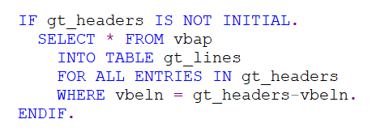
Creation of new indexes for SAP tables that are defined as “column store” should not be required, unless under exceptional circumstances.
Additionally, use SQL strict modes wherever applicable as per given link here.

    - Data Updates (SAP data)
SAP database tables are only to be updated through SAP provided code. This can be through the use of existing SAP transactions, SAP supplied BAPIs/IDOCs/Function Modules/Methods, or through the use of Batch Data (BDC) driven screen processing.
For update programs/logic, BAPIs/IDOCs/Function Modules/Methods should be used where available. The use of “screen scraping” methods (such as BDC programs) is not encouraged, and should only be used where there is no other suitable method available.
For mass-update programs, the use of LSWM should be considered before a custom program is developed. For S/4 HANA data load, use S/4 HANA Migration Cockpit for data load as per note 2287723.
All load programs that create or update SAP data need to generate an audit log that can be printed/downloaded. This log needs to show a list of successful updates, failed updates with error messages generated, and a summary of record counts (total, successful, error).
If a BDC Program is required, then the data input sessions should be limited to approximately 250 transactions per BDC group. Large BDC Programs are to be avoided due to the single-threaded nature of the batch environment. These programs are to be broken up into smaller batch programs, where appropriate.

    - Data Updates (non-SAP data)
Lock objects should be created for all ‘Z’ / ‘Y’ “primary tables” that can be updated via programs. The resulting function modules (ENQUEUE / DEQUEUE) must be used in the program(s) performing the updates. The primary table of a transaction (i.e. material table) should be identified and a lock placed when updating or deleting. For the display of critical data (no maintenance allowed while record is displayed), shared locks should be placed upon entry to the transaction.
There are several concepts when it comes to database transactions in SAP. The two main ones to be aware of are:

- Database LUW
- SAP LUW

(For details, please refer to the links listed in Section 1.4)

Database logical unit of work is the traditional database transaction. In SAP the database LUW is often closed implicitly whether the programmer wants it or not. This can lead to inconsistencies if the developer is not careful. It is for that reason that developers should avoid doing direct updates in the dialog task - even to ‘Z’ tables. A SAP LUW should be used instead.

A SAP LUW is an application level abstraction allowing you to bundle your updates and only commit them to the database when explicitly requested using the update task. The closing of a database LUW does not affect the SAP LUW if update task is used correctly.

All updates should be done in the update task. i.e. Use a SAP LUW.

Refer SAP lock mechanism, best practices and recommendations for different types of Types of update (Synchronous, Asynchronous and local update), Lock scope and And Lock wait policy after facing lock collisions

Wrong:
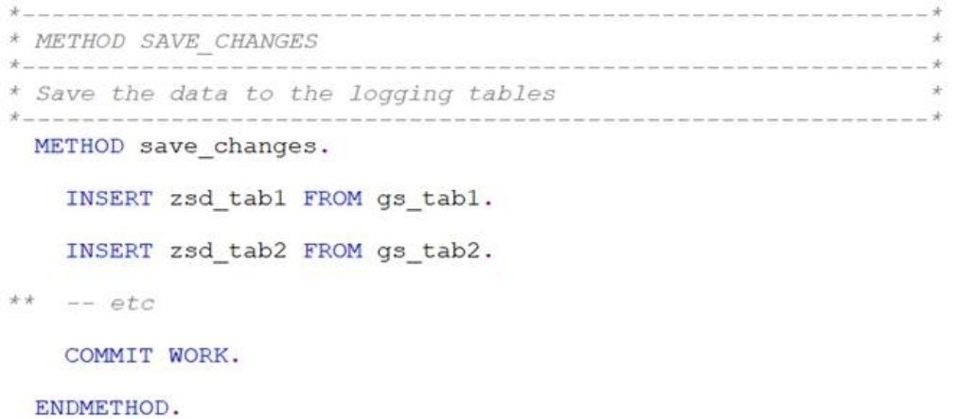

The main reason this is wrong is due to its use within other standard SAP LUW’s. For example, if this approach is used in a user exit, then the standard SAP LUW might never commit, but the database LUW might, which would mean the ‘Z’ tables are written to the database, and the standard tables are not. Follow best practices for IN UPDATE TASK given by SAP here

Correct:
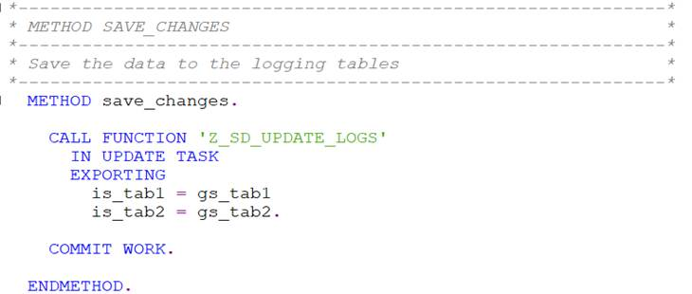

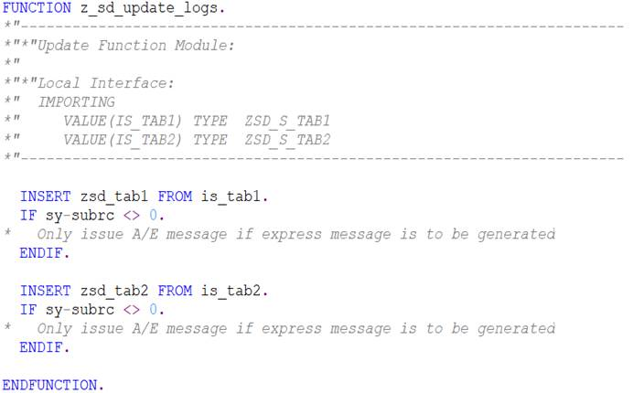

  - Security
    - Authorization Checking
By executing a Z program or transaction, an end user should not be able to view or update data that they cannot access via standard transactions (i.e. a Z program should not act as a “back door”).
Therefore, all ABAP code that reads data for reporting, or updates data, must execute the appropriate “authority-checks” before major processing commences. Failure to have the correct access rights to the data must stop the program/transaction from continuing.
All check objects created and used in programs/transactions must be documented thoroughly and given to the security administrator.
If the code branches out to other programs or transactions, additional authorization checks should be performed before the branching, unless the target program / transaction performs the checks.
use “AUTHORITY-CHECK” option of “CALL TRANSACTION” statement as per link given here. For security reason, it is highly recommended to use the option.

    - SQL Injection Protection
Dynamically generated SQL statements need to be reviewed and replaced with specific field lists, “from” and “where” clauses to avoid SQL Injections.
Example of a simple SQL injection:
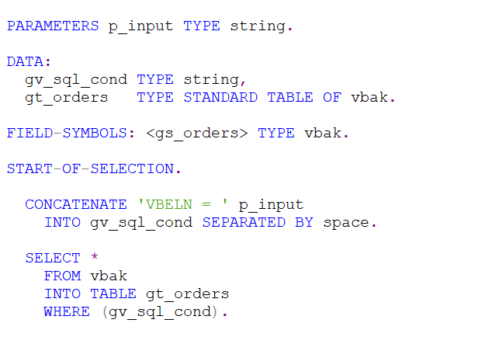
In this case, if “p_input” contains the string “ ‘xxx’ or vbeln <> space ”, all entries in the table will be selected, which is not the intended outcome.
If the use of dynamic field lists, “from” or “where” clauses cannot be avoided, additional checks on this data must be performed to eliminate possible injections.

    - Change logging
Also refer to Sections 4.19.1.
Where data is changed via a program, BAPI, user exit, or other process, application logging should be used to record the changes made by the module.
Follow best practices to record Application Logging as per given link here

    - User Accounts and Passwords
Do not hard code user IDs and/or passwords in programs.
Where additional (non-dialog) user accounts are required for interfacing, the security team need to be advised of the access required by the account so that the appropriate access can be set up. Broad access (such as “SAP_ALL” and “SAP_NEW”) will not be granted.

- ABAP Performance Standards
There are many SAP Press books, internet sites and papers that cover this topic. This section will briefly discuss the various issues that developers need to be aware of when building programs.
As a general rule: all programmers should aim for building the most efficient code as possible.
The key areas that developers need to consider are:
- General structure of the code
- DB accesses
- Memory
  - General Code Structure
Code should be well designed and structured.
The same data should not be selected more than once. Likewise, the same computations should not be performed multiple times.
There should be no “dead” code or code that (for example) computes a value which is never used.

  - DB accesses
When writing DB select code (ABAP “select” statements), the developer needs to consider the number of rows and columns returned, and the data access path, as this can impact on performance.
Some points to consider:
- Avoid nested selects; use Joins, Data Dictionary Views, or ABAP CDS views
- Consider adding CTE, UNION, subqueries, and AMDP to avoid nested selects. They can be helpful to get better performance.
- Avoid “select *” on tables with many fields, especially if only a few fields are required by the program. Even more than a few fields are read, it is important to restrict columns to retrieve from column store table. Especially for tables with lots of fields. (e.g. MARA)
- If the table is defined as “row store”, always access large tables via the primary key or an index. If the table is defined as “column store”, consider any indexes that already exist, though it should not be necessary to create new indexes (unless under exceptional circumstances)
- Avoid loops containing “select single” or any types of DB accesses.
- Consider the use of SAP HANA “Code Pushdown” features, such as ABAP CDS views or ABAP Managed Database Procedures (AMDP). SAP provides many tools to assist with analysing database access that can assist here (eg. ABAP test cockpit (SATC), SQL Monitor (SQLM) and SQL Performance Tuning Worklist (SWLT)).

  - Memory
How variables are defined and used can also impact on performance.
Some points to consider:
- Declaration of internal tables; consider hashed and sorted tables
- Consider the use of secondary indexes on internal tables instead of copying tables to access data via a different key
- STANDARD TABLE may have more performance benefit, if there are a lot of record changes to an internal table as well as a lot of read operations.
- Use the “free” command for tables that are no longer used by the program
- For arithmetic, consider using floating point (over packed) data

  - Conclusion
There is no “one size fits all” approach when it comes to the performance of ABAP programs; certain approaches suit some situations, but not others.
The ABAP language is evolving; some commands are now better optimized in later versions. Each release of SAP has given developers new syntax and coding options, and the use of these newer features should be considered if they deliver performance improvements.
The introduction of HANA as a data base platform now allows for more computations at this level (“Code Pushdown”), and developers need to become familiar with the various techniques available here to see if they can be used to improve performance for the situation at hand.

The recommendation here is that programmers try the various options available to them, and analyse these via the tools provided by SAP, such as: SQL trace (ST05), Runtime Analysis ) SAT (old transaction SE30) and ABAP Trace ST12, ABAP test cockpit (ATC), SQL Monitor (SQLM) and SQL Performance Tuning Worklist (SWLT)).

- ABAP Standards and Procedures for “Lift and Shift” objects
The purpose of this section is to outline the general rules to follow when code is copied from a legacy SAP R/3 system into S/4 HANA, and only technical upgrade steps are to be performed so that the code will execute in an S/4 HANA system. This is also known as “Lift and Shift”.
For a development object to be considered for “lift and shift”, the code first needs to be reviewed to ensure that:
- The code is frequently used in the legacy system
- The code that is easy to understand, support and maintain
- The code that uses acceptable database update techniques
- The design assumptions that are still valid
- The code does not require additional enhancements to SAP code
- The code does not introduce any security concerns

  - Object copy
Copy all objects required from the source system into the target. Ensure that the external naming conventions for objects in S/4 is adhered to (i.e. Objects are named as per Section 3.2 of this document).
Within the code, leave all existing comments as is.
Where a previous “main documentation block” has been maintained, leave this in place and add an entry to the Revision History indicating the date, developer name/user ID, reason for change (“Import program into S/4”) and details of any further changes made via remediation. If no “main documentation block” has been maintained, insert the template version at Appendix A and include a detailed description of the import and changes made via remediation.
Existing code, at this point, does not need to be redeveloped to comply with the ABAP internal naming standards (Section 3.3), unless there are a small number of statements (< 200).

  - Object Remediation
The aim of the remediation step is to make the code technically sound for the S/4 environment, and hopefully reduce the likely hood of errors during testing. This step must be completed before unit testing is undertaken.
For object remediation, the following steps need to be completed:

    - Code corrections
      - Data base access
All “select” statements need to be reviewed.
Previous data bases used within SAP R/3 environments often provide sorted data, so the ABAP code developed may have assumed a certain order. This order is no longer guaranteed by SAP HANA.
For example:
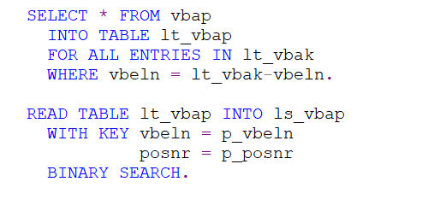
This code may have worked with other data bases (like Oracle), because the select results are usually returned already sorted by the primary key. However, with a HANA database, a sorting needs to be explicitly specified. Replace the above code with:
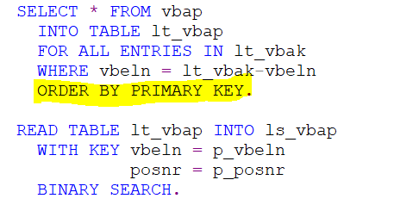
“Select single” statements can also be problematic, as often developers have used this statement without supplying the full primary key (again relying on an implicit data sort).
For example:
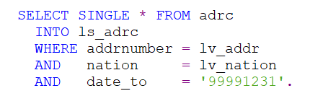
Replace this with:
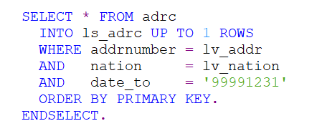
Also check for nested select statements, select *, etc. and correct this where possible.
Check to see if common joins performed in ABAP or SE11 Views can be replaced with the new de-normalized tables.
Eg. MKPF & MSEG: review MATDOC;
BKPF & BSEG: review ACDOCA;
VBUK, VBUP: review status fields in the main tables (VBAK, VBAP)

      - Calls to Function Modules / Methods
Check all calls to SAP and ‘Z’ / ‘Y’ external modules/methods. If the external module is obsolete, replace this with the new version.
For ‘Z’ / ‘Y’ objects, check if a suitable SAP module is now available. If so, use this.

      - BDC code
If code contains updates using the BDC technique, replace this with a suitable BAPI, Function Module or Method (if available).

      - General checks
Run the code through “Pretty Print”. Review the code to see if anything can be tidied up (such as replacing hard coded values with constants, removal of “dead” code, etc.).

    - Extended Program Check
Run Extended Program Check (Program -> Check -> Extended program check).
Sample results:
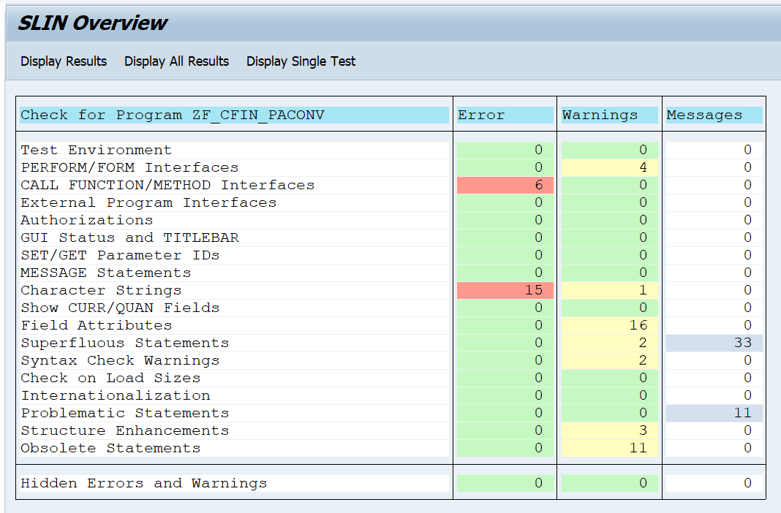
Fix all errors. Clear “Obsolete Statements” warnings if time permits.

    - Code Inspector
Run Code Inspector with a variant that includes S/4 Readiness checks (Program -> Check -> Code Inspector).
Sample results:
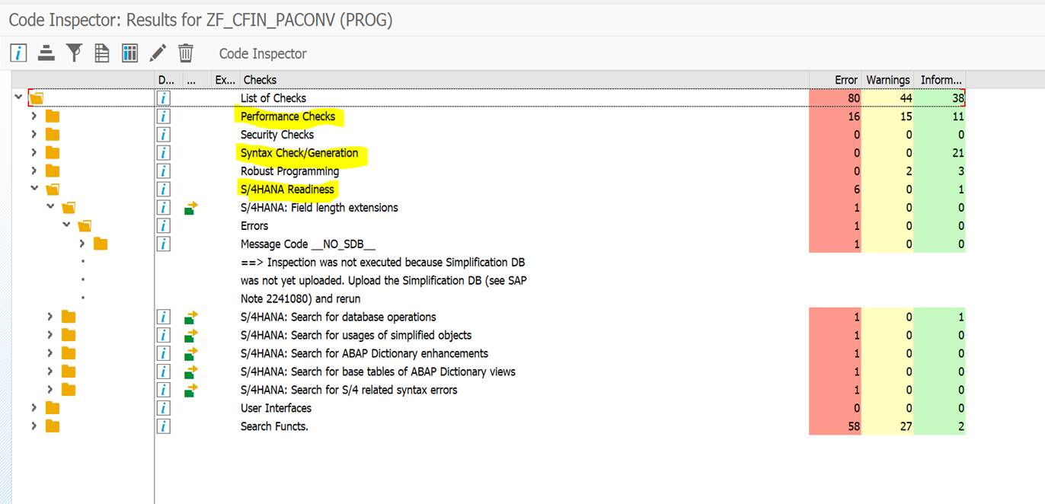
Fix all errors. Then focus on: Performance Checks, Syntax Check/Generation, S/4 HANA Readiness.
Note: Not all warnings listed here are relevant. Review the list and adjust the code (if needed).
- Appendices
  - Appendix A – Code Comment Block
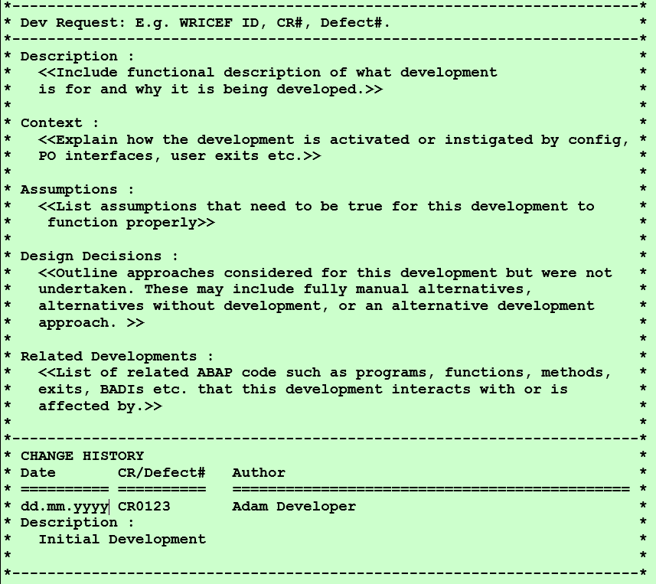
(The comment block can be found in system SDA, program ZZCOMMENT_BLOCK_TEMPLATE)

Description
This should contain the most text. It’s important to explain in plain English what this development is doing and why.

Context
This section explains the context for this development. This helps the support programmer to see where this routine is configured, as well as where to find at other program code which could be investigated when working on a problem.

Assumptions
The assumptions section is important for the support programmer to know that certain conditions have been considered but not programmed for. Without this section, the support programmer is not sure if this situation was considered when the development was done.

Design Decisions
This section outlines what other approaches were considered for this development but weren’t undertaken. These may include designs that may be fully manual, designs that require no development, or other development approaches. This helps the support programmer in not needing to ‘re-invent the wheel’ when investigating a problem.

Related Developments
It’s important to know this, because this is not always obvious. There may be other routines, exits, programs etc. related to this development. Detailing this helps the support programmer to know how their changes can impact other related developments, and what to test when testing their changes.

  - Appendix B – Workstream ID and SAP Modules
Workstream ID / Process Area | SAP Module
GTS | GTS
OTC_SD | SD
OTC_PM | PM-CS
PTD | QM, PP
PTP | MM
RTR | FICO, CLM, FSCM, RAR
WTD | EWM, LE

  - Appendix C – TR Naming Convention
The TR naming convention generally flows from the Work Package and Work Item created from SolMan. When the TR is generated, it follows the naming convention below:
Object | Convention | Examples | Comments
Transport Request | <Work Item ID> : <Work Item Description> | 8700000069 : F-194-SAP (Technical): PO form except SIP | <Work Item ID> is automatically generated by the SolMan System  <Work Item Description> consists of the WRICEF ID and its short description that can be modified to include labels to differentiate TRs

